Software Design Document
Group 12
（张尚峰，黄蔚均、刘安喆）
RapMix - An AI-powered lightweight mixing application
- Introduction：
RapMix is an AI-driven lightweight mixing application designed to democratize professional-grade music production for aspiring creators, particularly targeting the 16-25 age demographic. The project's overarching goal is to eliminate traditional barriers to music creation—such as high equipment costs, technical complexity, and expensive studio services—by leveraging advanced AI algorithms. The app enables users to transform raw vocal recordings captured on mobile devices into polished, studio-quality tracks through intuitive, template-based mixing and intelligent audio processing. Its scope encompasses core functionalities including AI-powered noise reduction, vocal enhancement, style matching, a customizable template library, and an integrated community platform for sharing and collaboration. By fusing accessibility with professional output, RapMix aims to foster a new ecosystem where music creation is seamless, affordable, and inclusive.
- Requirements Specification:
The project targets users aged 16–25, primarily students and independent creators, who face significant barriers to music production: suboptimal recording environments, high complexity of traditional mixing software, and prohibitive costs of professional services. User requirements thus prioritize accessibility, affordability, and simplicity, enabling professional-grade mixing solely via mobile devices with minimal learning curve.
Functional requirements are structured into four core modules:
- Intelligent Mixing: AI-driven noise reduction, vocal extraction, style matching, and automated beat alignment.
- Template & Customization: A library of genre-specific templates (e.g., Hip-Hop, R&B) supporting user-defined presets.
- User System: Profile management, achievement-based leveling (Lv.1–10), play history analytics, and social media integration.
- Community & Interaction: Features for publishing works, comments, likes, rankings, and challenge-based events to foster engagement.
Non-functional requirements include cross-device compatibility (Android 11+), API response under 500ms, and install package size below 100MB.
- Overall Design:
The RapMix application is architected around a modular, three-tier system designed to deliver professional-grade audio mixing through an intuitive mobile interface while leveraging cloud-based AI processing.
Architectural Overview:
The system employs a client-server model. The client tier, built with Kotlin for Android,provides the user interface and handles local tasks such as audio capture and preliminary processing. The server tier consists of a high-computing-power cluster responsible for resource-intensive AI model inference, including style matching, noise reduction, and vocal extraction. Communication between tiers is managed via a RESTful API using Retrofit, ensuring efficient and reliable data exchange for operations like file uploads, processing requests, and community interactions.
Core Functional Modules:
The app's primary functions are organized into four integrated modules:
Intelligent Mixing Engine: The heart of the application, this module integrates self-learning AI algorithms (via TensorFlow Lite) to perform core audio transformations. It automates key processes including intelligent denoising, precise vocal isolation, beat alignment, and application of style effects from a template library.
Template & Style System: A central repository of pre-configured mixing templates spanning genres like Hip-Hop, R&B, and Pop. The system supports user customization, allowing creators to save and reuse personal preset configurations, fostering a unique sonic identity.
User Management & Growth System: This module manages user identity through profiles, a leveling system (Lv.1-10), and achievement badges. It provides data analytics dashboards for tracking creations, followers, and listening habits, designed to incentivize continued engagement and skill development.
Community & Interaction Platform: Facilitates user engagement through features for publishing finished works, commenting, liking, and participating in ranked challenges. This social layer is supported by real-time synchronization mechanisms, transforming the app from a tool into a creative ecosystem.
Key Design Principles:
The design prioritizes separation of concerns for maintainability, cloud-based processing to ensure consistent performance across diverse mobile hardware, and a user-centric interface that simplifies complex audio engineering tasks into a streamlined, three-step workflow. This structure enables the core value proposition: delivering studio-quality audio post-production directly to users' mobile devices.
- User Interface Design:
This interface design adheres to the core concept of "function-driven, intuitive noise reduction, and emotional connection". The overall architecture adopts the classic bottom navigation bar structure, consistently providing four primary entry points: "Creation", "Community", "Drafts", and "My", ensuring clear core function paths and efficient switching. The visual system uses a dark immersive interface as the canvas, establishing a professional creation tone; the brand theme color (#4ECDC4, fresh blue-green) serves as the core interaction color, running through buttons, selected states, and key data; the accent color (#FF6B6B, vibrant red) is used for important reminders, badges, and likes, among other highly interactive elements, jointly constructing a visually rhythmic and technologically advanced visual recognition system. The fonts have been specially selected and matched to ensure the smooth reading of mixed Chinese and English and the unity of interface aesthetics.
In-depth Analysis of Core Function Interface
Creation Center Interface: As the core production tool, design focuses on complexity management. The center of the interface is a multi-track timeline visualization area, clearly and simultaneously presenting "main melody", "Beat rhythm" and other audio tracks, supporting intuitive dragging and editing operations. Professional audio processing functions are modularized into user-friendly controls: such as a "pulse purification" button for one-click noise reduction, and an "intelligent style library" presented in a horizontally scrollable style card (Trap, Old School, Urban), enabling one-click application and preview of styles. The "Creation Challenge" section is strategically placed in the upper part of the page, using prominent cards to display this week's theme (such as "Future Urban Fusion") and participation incentives, effectively combining the tool attributes with the stimulation of creative inspiration.
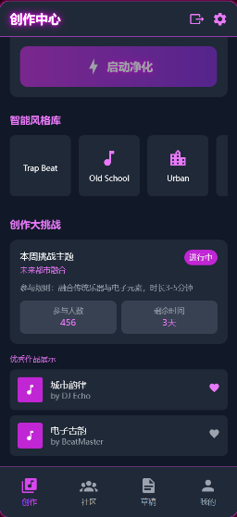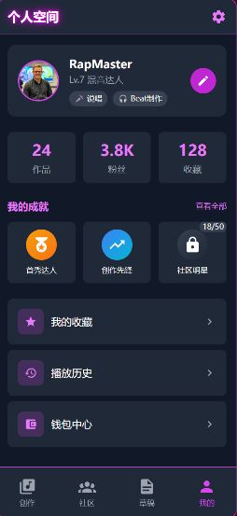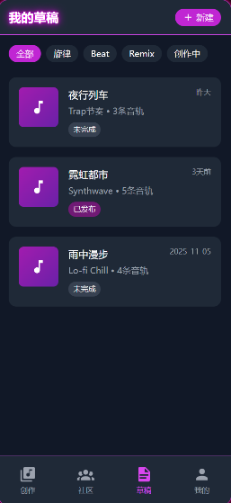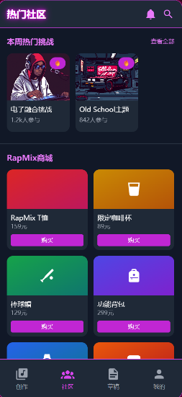
Community and Mall Interface: Adopting an innovative layout that integrates information flow with e-commerce. The top section features a "Weekly Popular Challenges" aggregation entry, which creates an active atmosphere by displaying the number of participants. Below, the "RapMix Mall" (selling T-shirts, coffee cups, smartwatches, etc., brand accessories) is innovatively arranged in an alternating manner with the user-generated "Latest Updates" information flow. This design seamlessly integrates product exposure into the daily browsing experience, while the like and comment functions for user activities (such as posting works, participating in challenges) are directly visible, forming a complete community ecosystem loop of "creation - display - interaction - consumption".
Draft Box Management Interface: Focused on improving the efficiency of the creative process. It presents each draft project in a card list view, with key information presented in a structured manner: project name, music style tags, track count, status badges ("Not Completed", "Published"), and the last modification time. At the top, there are multi-dimensional filtering labels such as "All, Melody, Beat, Remix", helping users quickly locate their drafts among a large number of them, reflecting a deep understanding of the fragmented and iterative nature of the user's creative process.
Personal Space Interface: Dedicated to visualizing the identity and growth of creators. The interface adopts a dashboard format. The top section prominently displays the user's virtual identity: personalized avatar, level badges (e.g., Lv.7 Mix Expert), and domain tags. Core creative data (number of works, number of followers, number of collections) is presented in large font and displayed in an intuitive dashboard format, providing immediate feedback on achievement. The "My Achievements" system is presented in a gamified form with unlock progress bars and a badge wall. The bottom grid neatly arranges practical function entrances such as "My Collections", "Play History", and "Wallet Center", fully meeting the personal management needs of users.
Interactivity details are consistent with the system
The entire application adheres to a highly componentized and standardized design language. Button, card, list item, and other interactive elements maintain uniform rounded corners, shadows, and feedback animations (such as pressed state) across all interfaces. Through a strict spacing system, scientific font hierarchy (titles, body text, prompt information), and appropriate color contrast, a self-explanatory visual information hierarchy is established. Even when presenting complex multi-track audio information or dynamic community content, the interface can maintain a high degree of tidiness and order, ensuring that the user's cognitive load is minimized, ultimately achieving the design goal of "lightweighting" professional-level audio studios into the user's pocket.
- Key Technologies:
The technical implementation of this project is centered around three core aspects: intelligence, lightweight design, and high performance. In the AI audio processing layer, a self-learning mixing algorithm based on TensorFlow Lite is integrated, which can perform low-latency inference on local devices, enabling continuous learning of user preferences and personalized style matching. At the same time, advanced sound source separation technology is adopted for intelligent noise reduction and high-precision voice extraction, ensuring that pure and dry sound can be output even in complex recording environments. To support complex model computations and high concurrent requests, a high-performance server cluster is deployed at the backend, communicating with the client through RESTful API (constructed using Retrofit), and adopting sharding upload, asynchronous processing, and caching strategies to control the average audio processing time within 3 minutes, and optimizing the API response time to below 500 milliseconds.
The main technical challenges encountered during the development process include: Firstly, achieving a balance between high-performance AI inference and resource usage on mobile devices, which is addressed through model lightweighting and local caching mechanisms; Secondly, ensuring UI consistency and smooth experience across different screen sizes and Android versions (11-13), which is accomplished by using ConstraintLayout for responsive layout and conducting specialized performance optimization for low-end devices; Thirdly, building a highly available real-time community interaction system, which is ensured through WebSocket connections and efficient state synchronization mechanisms to guarantee the immediacy of interactions such as comments and likes.
- Testing and User Experience Analysis:
The application underwent comprehensive testing, including functional, compatibility, UI, and performance tests across multiple Android devices (e.g., Redmi K40, iQOO Neo5) and OS versions (11-13). Key findings revealed interface misalignment on certain devices, prolonged login response times, and slow loading on low-end hardware. Solutions involved adopting ConstraintLayout for responsive UI, optimizing authentication logic with asynchronous processing and caching, and implementing code optimization with lazy loading and image compression to enhance performance. User experience was evaluated through structured feedback collection. Positive remarks highlighted the intuitive interface and useful personal page features. Critical feedback pointed to a monotonous visual design, overly dark button colors, and a desire for richer functionality. In response, iterative improvements were implemented, including enhanced chat controls (screenshot/delete), expanded health management features, added third-party login options (Google/WeChat), and a comprehensive UI refresh with optimized colors and decorative elements. These targeted optimizations resulted in measurable gains: user satisfaction increased from 78% to 92%, daily active users grew by 35%, and user retention improved by 28%, validating the effectiveness of the testing and user-centered refinement cycle.
- Conclusion:
The RapMix project has successfully developed a functional AI-powered mobile mixing application that significantly lowers the barriers to professional music production. Key achievements include building an integrated ecosystem featuring an intelligent mixing engine, a style library, a user growth system, and a community platform, which collectively drove user satisfaction from 78% to 92% and increased daily active users by 35%. Development challenges, such as mobile AI optimization and Android fragmentation, were addressed through model lightweighting, responsive UI design, and real-time synchronization technologies. Future development will focus on short-term enhancements to community features and AI audio quality, alongside a long-term strategy to build a sustainable creator economy with advanced AI tools and cross-platform collaboration, positioning RapMix as a leading next-generation music creation platform.

